**ASSIGNMENT-2**

**Domain:** IoT

**Team members:**

SUBALAKSHMI G-513119106314

RANJITH KUMAR R-513119106311

TAMIZH D-513119106316

VELMURUGAN V-513119106317

**OUTPUT:**

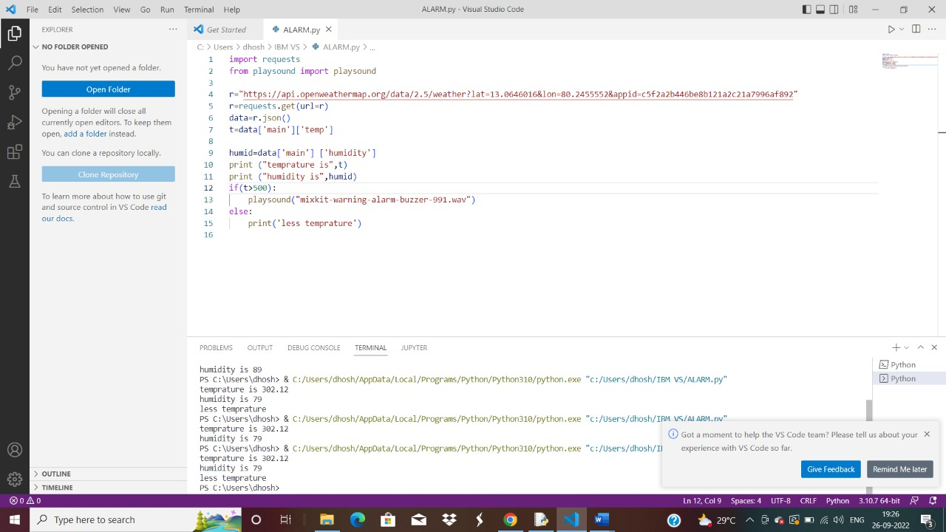

**CODING:**

**import requests**

**from playsound import playsound**

**r="https://api.openweathermap.org/data/2.5/weather?lat=13.0646016&lon=80.2455552&appid=c5f2a2b446be8b121a2c21a7996af892"**

**r=requests.get(url=r)**

**data=r.json()**

**t=data['main']['temp']**

**humid=data['main'] ['humidity']**

**print ("temprature is",t)**

**print ("humidity is",humid)**

**if(t>500):**

**playsound("mixkit-warning-alarm-buzzer-991.wav")**

**else:**

**print('less temprature')**